**1.**

print( "Name :Kanav ShahPatel")

print("Roll Number : 24BEE107")

def largest_and_smallest_of_two(a,b):

largest = max(a,b)

smallest = min(a,b)

print(" largest :",largest )

print("smallest :",smallest)

largest_and_smallest_of_two(7,10)

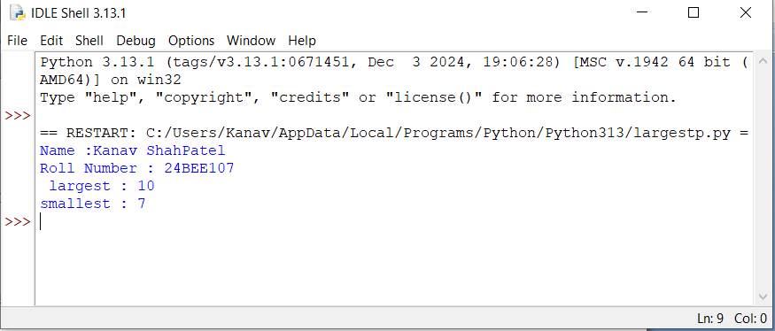

**2.**

print( "Name :Kanav ShahPatel")

print("Roll Number : 24BEE107")

def largest_and_smallest_of_three(a,b,c):

largest = max(a,b,c)

smallest = min(a,b,c)

print(" largest :",largest )

print("smallest :",smallest)

largest_and_smallest_of_three(6,12,10)

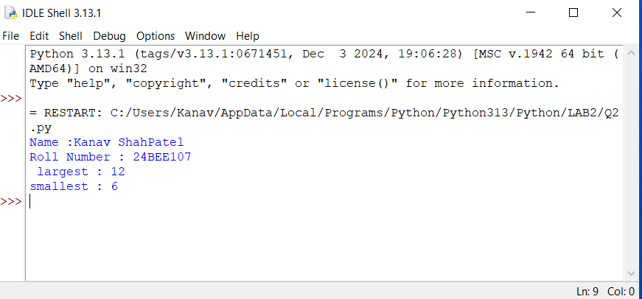

**3.**

print( "Name :Kanav ShahPatel")

print("Roll Number : 24BEE107")

def check_odd_even(number):

if number % 2 == 0:

print("Even")

else:

print("Odd")

check_odd_even(8)

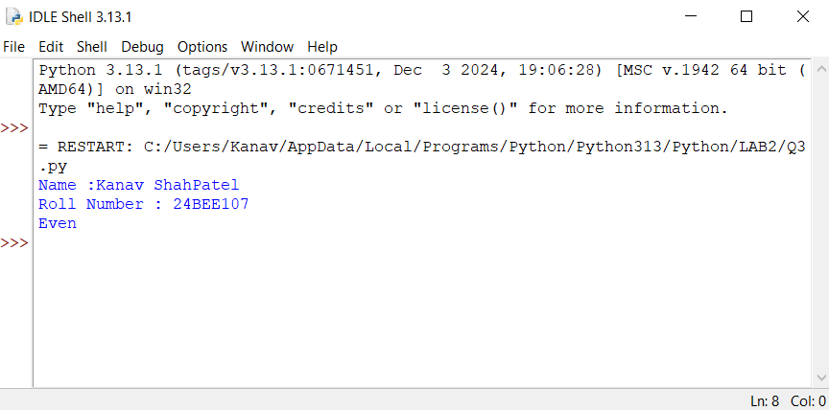

**4.**

print( "Name :Kanav ShahPatel")

print("Roll Number : 24BEE107")

def check_divisible_by_10(number):

if number % 10== 0:

print("Divisible by 10")

else:

print( " Not divisible by 10")

check_divisible_by_10(50)

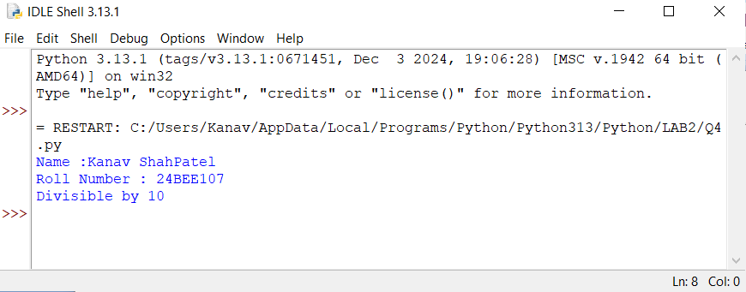

**5.**

print( "Name :Kanav ShahPatel")

print("Roll Number : 24BEE107")

def check_age(age):

if age <18:

print("Minor")

else:

print( "Major ")

check_age(17)

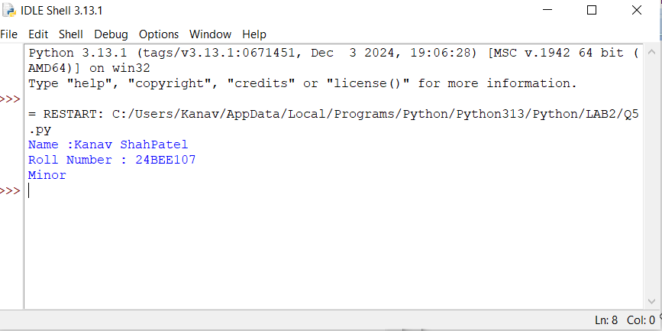

**6.**

print( "Name :Kanav ShahPatel")

print("Roll Number : 24BEE107")

def count_digits(number):

digits =len(str(number))

print("Number of digits :",digits)

count_digits(12345)

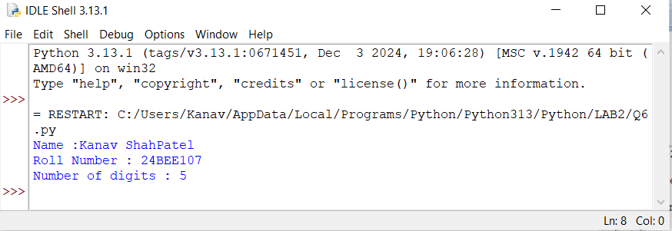

**7.**

print( "Name :Kanav ShahPatel")

print("Roll Number : 24BEE107")

def check_leap_year(year):

if ( year % 4 ==0 and year %100 !=0) or (year %400 ==0):

print("Leap year")

else:

print( " Not a leap year ")

check_leap_year(2020)

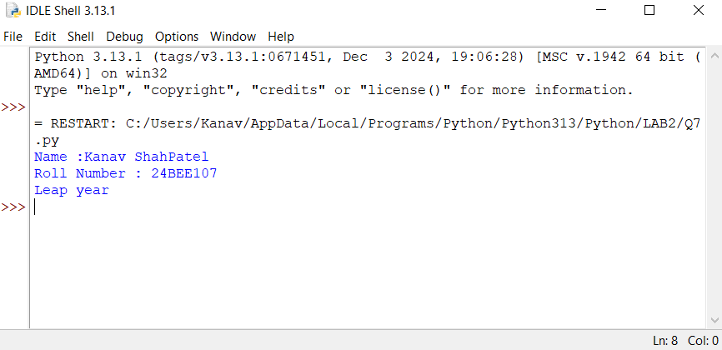

**8.**

print( "Name :Kanav ShahPatel")

print("Roll Number : 24BEE107")

def check_triangle_validity(angle1,angle2 ,angle3):

if angle1 +angle2 +angle3 == 180:

print("Valid triangle")

else:

print( " Invalid triangle ")

check_triangle_validity( 60,60,60)

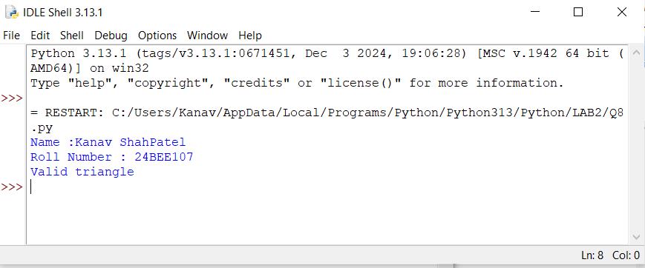

**9.**

print( "Name :Kanav ShahPatel")

print("Roll Number : 24BEE107")

def absolute_value(number):

abs_value =abs(number)

print("Absolute value:",abs_value)

absolute_value(-20)

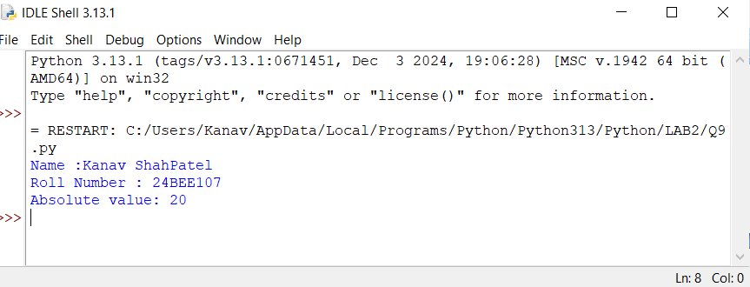

**10.**

print( "Name :Kanav ShahPatel")

print("Roll Number : 24BEE107")

def compare_area_perimeter(length,breadth):

area =length*breadth

perimeter=2*(length+breadth)

if area >perimeter:

print("Perimeter is greater than or equal to Area ")

else:

print("Area is greater than or equal to Perimeter ")

compare_area_perimeter(12,8)

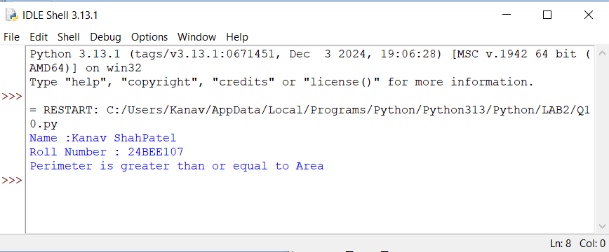

**11.**

print( "Name :Kanav ShahPatel")

print("Roll Number : 24BEE107")

def check_collinear(x1,y1,x2,y2,x3,y3):

if (y2-y1)*(x3-x2) == (y3-y2)*(x2-x1):

print("Points are collinear")

else:

print("Points are not collinear")

check_collinear(1,1,2,2,3,3)

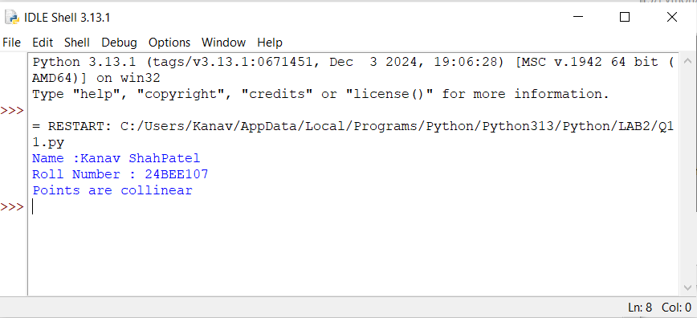

**12.**

print( "Name :Kanav ShahPatel")

print("Roll Number : 24BEE107")

import math

def check_point_circle(x,y,circle_x,circle_y,radius):

distance = math.sqrt((x-circle_x)**2+(y-circle_y)**2)

if distance < radius:

print("Points lies inside the circle")

else:

print("Points lies outside the circle")

check_point_circle(1,1,0,0,5)

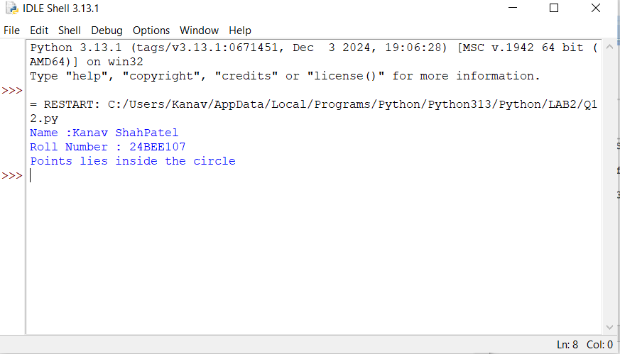

**13.**

print( "Name :Kanav ShahPatel")

print("Roll Number : 24BEE107")

def number_to_words(number):

words =[ "zero","one","two","three","four","five","six","seven","eight","nine","ten","eleven","twelve","thirteen","fourteen","fifteen","sixteen","seventeen","eighteen","nineteen"]

print(words[number])

number_to_words(15)

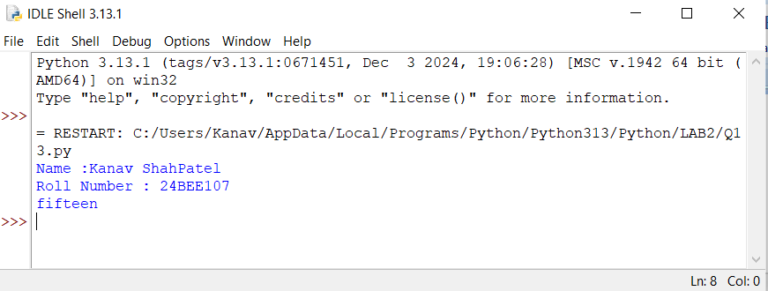

**14.**

print("Roll Number : 24BEE107")

def calculate_results(marks1,marks2,marks3):

total =marks1 + marks2 + marks3

average=total/3

print("Total Marks:",total)

print("Average Marks:",average)

if marks1 <=39 or marks2 <=39 or marks3 <=39:

print("Result:Fail ")

else:

print("Result:Pass")

for marks in [marks1,marks2,marks3]:

if marks <=39:

grade ='F'

elif 40 <=marks <=44:

grade ='P'

elif 45 <=marks <=49:

grade ='C'

elif 50 <=marks <=54:

grade ='B'

elif 55 <=marks <=59:

grade ='B+'

elif 60<=marks <=69:

grade ='A'

elif 70 <=marks <=79:

grade ='A+'

else:

grade ='O'

print(f"Marks:{marks},Grade:{grade}")

calculate_results(65,75,85)

